**2024 IABEM Workshop on the BIE/BEM and AI Computing**

**December 2 - 3, 2024, Shenzhen, China**

**Registration Form**

**(Please type. Each registrant should submit one form. English or Chinese is accepted)**

**Name (English/Chinese): ______________________________________________________________________**

**Gender (Male/Female)：_______________________ Title:__________________________________________**

**Affiliation: ______________________________________________________________ _____________________________**

**If Needed, Type of Invoice (General/Special): _______________ Tax ID: _______________________________________**

**Tel: ________________________________________ Email: __________________________________________**

# Registration Fees (Please check ✓)

|  |  |  |
| --- | --- | --- |
|  | Registration Type | Registration Fee*  (Before Oct 31, 2024) |
| Workshop | Full Registration | CNY 1200 |
| Student | CNY 600 |
| Total CNY |  | |

**\*** The workshop registration fee includes the lecture materials and lunches.

**Please email the completed form and payment record to Ms. Sun Yu, the Secretary of the Workshop, at the e-mail address: suny3@mail.sustech.edu.cn.**

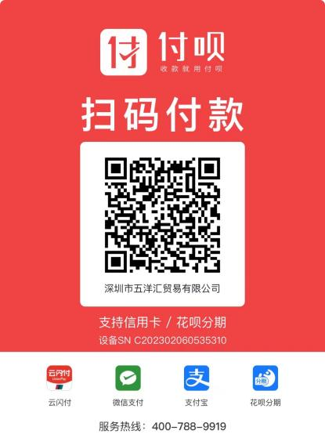You may pay for the registration fee by using a credit card on site of the workshop or by using bank wire transfer. The bank info is listed below. Besides, you can pay it through Alipay or WeChat using the QR code below. Make sure that you mention the purpose of your payment: 2024 IABEM Workshop, your name and affiliation.

**Bank Account Information:**

Account Name: 深圳市五洋汇贸易有限公司

Bank Name: 光大银行深圳海滨支行

Bank Account No.: 39060188000119450

Tel: +86 (0755) 8622 0298

Note: For 2024 IABEM Workshop

Name + Affiliation